**CSC 1032 Lab Report 1**

**Name – Phone Myat Thu**

**Student ID - 230668418**

**Week 1**

**Task-1**

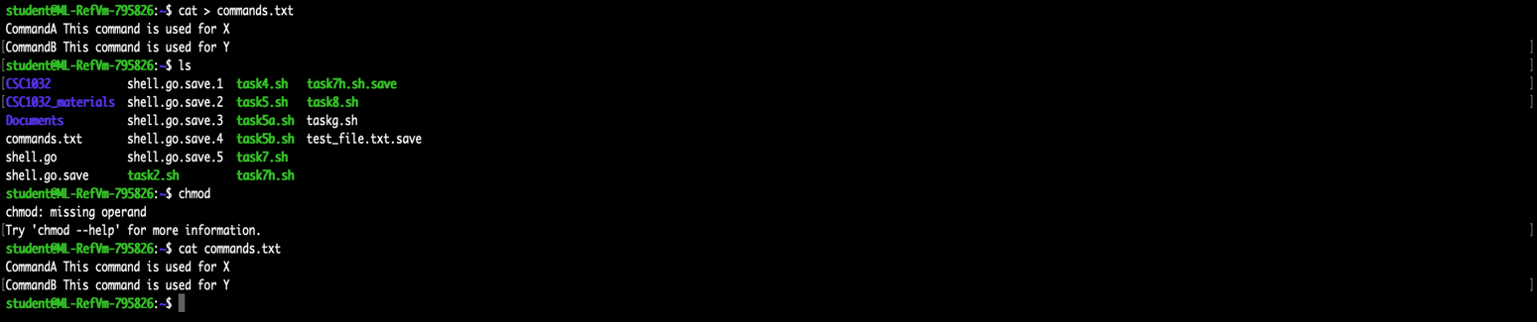

There is a commands.txt file in my directory and if I type “cat commands.txt”, it will show the log of commands I wrote in the file.

**Task-2**

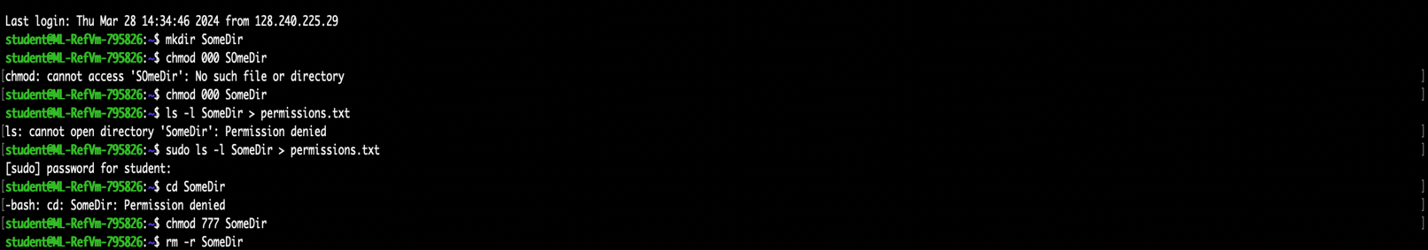

I used mkdir to create SomeDir file and tried to change the permission, but it didn’t work hence I used sudo and tried to move the file to the directory but received permission denied. Using “chmod 777 SomeDir” for full permission and “rm -r SomeDir” for deleting it.

**Task 3**

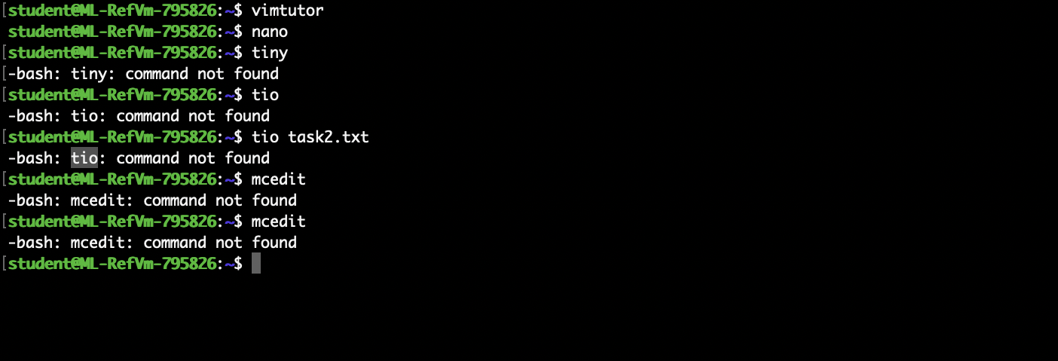

While vim and nano are available, tiny and mcedit aren’t available. From my point of view, I prefer nano. For vim, we can use the y operator to copy the text and p to paste it. In nano, we use ctrl +6 to mark and ctrl + k to cut, finally ctrl + u to copy the text and use it (ctrl + u) again to paste the text.

**Week 2**

**Task-1**

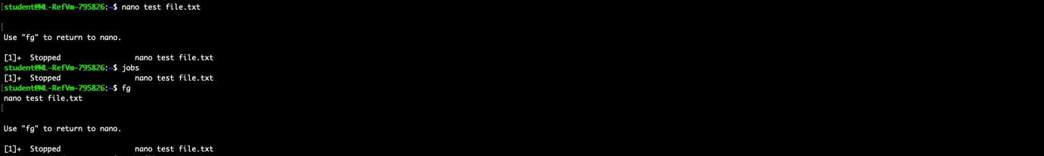

In this program editor, we did nano test_file.txt and run the process but can stop the process by pressing ctrl + z and can be restore using the fg (foreground).

**Task-2**

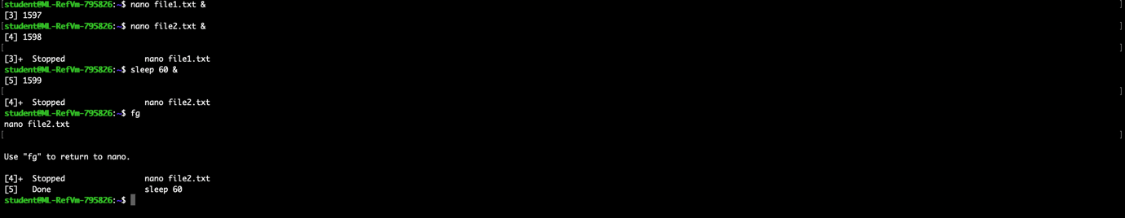

In task 2, the processes are started directly using the “&” and it just stop working for a minute if use commands “sleep 60 &” and restore using fg.

**Task-3**

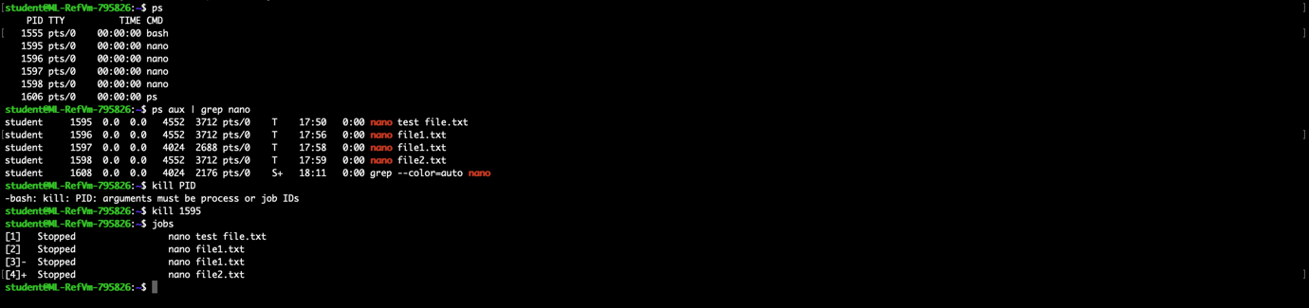

Running “ps” command shows processes associated with the current terminal. The “kill” command sends a signal to terminate. After killing the processes, the “jobs” commands can be used to list background processes.

**Task-4**

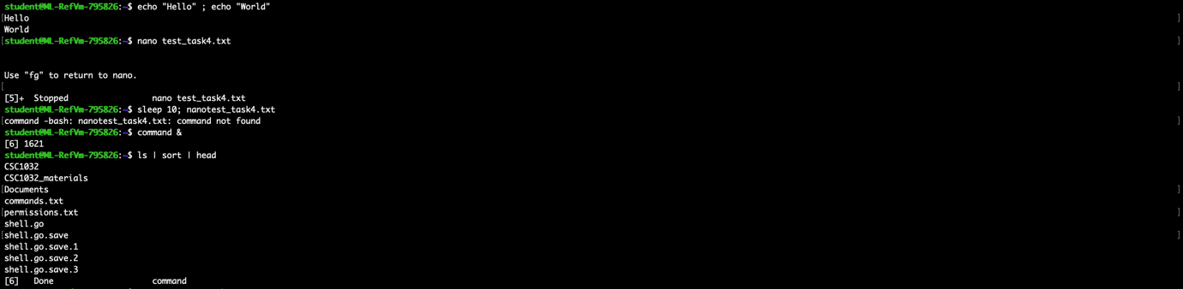

In task4, echo “Hello” ; echo “World” the echo commands separated by a semicolon that acts a command separator to be executed on the same line. The “sleep 10; nanotest_task4.txt” command paused the shell for 10 seconds. The pipes ( ‘|’ ) connect the multiple commands together.

Task-5

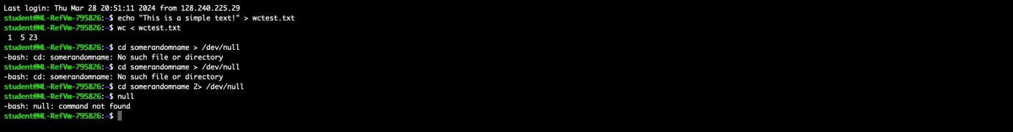

In these examples, null is used for output redirection, ensuring that any output directed to is effectively discarded. This is useful for suppressing the error messages or unwanted output.

A

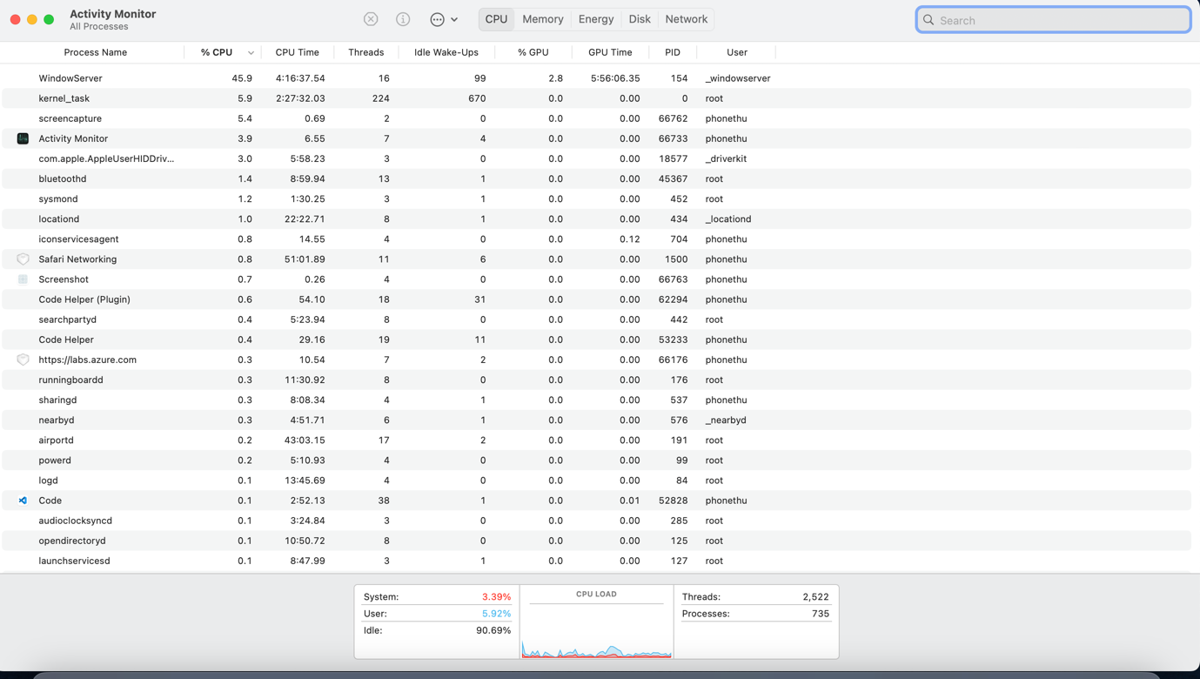

**Week -3**

Task-1



Task -2

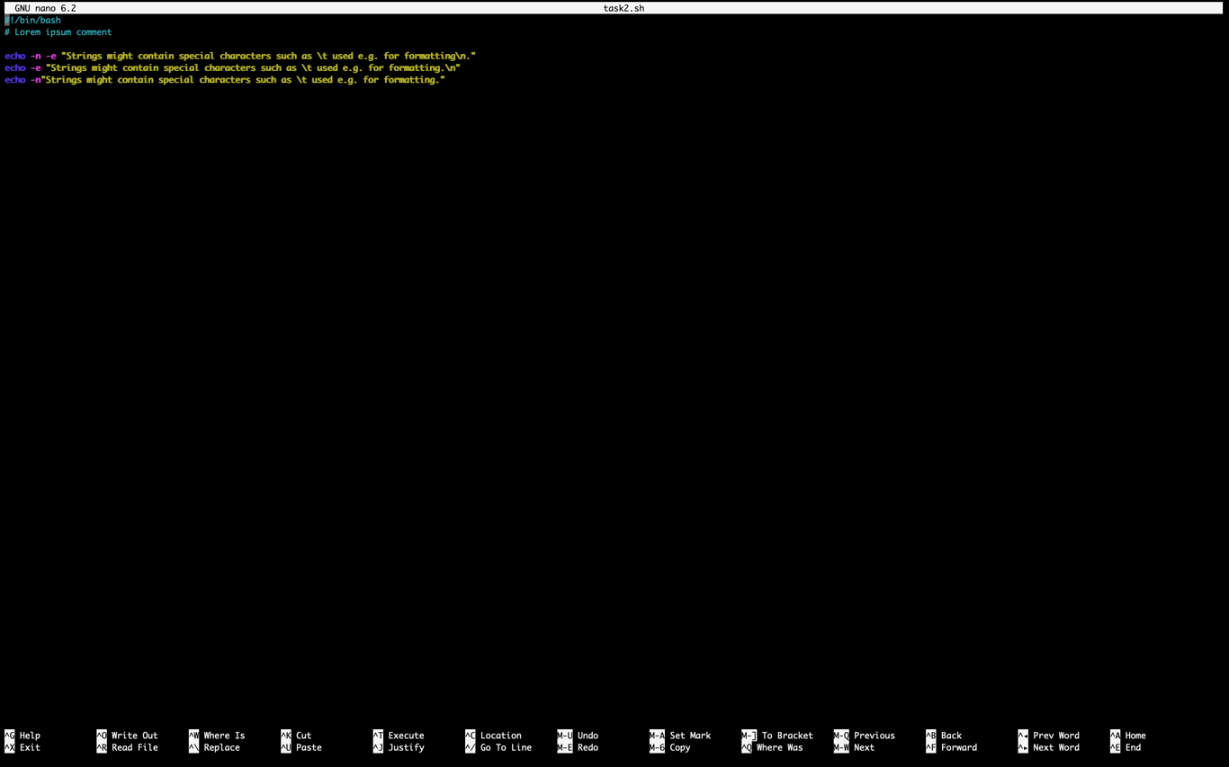

The other escape characters that I can use in string are ‘\n’, ‘\r’, ‘t’ etc. If I remove the -n, there will be a tab space after as but if I remove -e, there will not be a tab space but instead it will just print as a string that I showed my results in task3.

Task -3

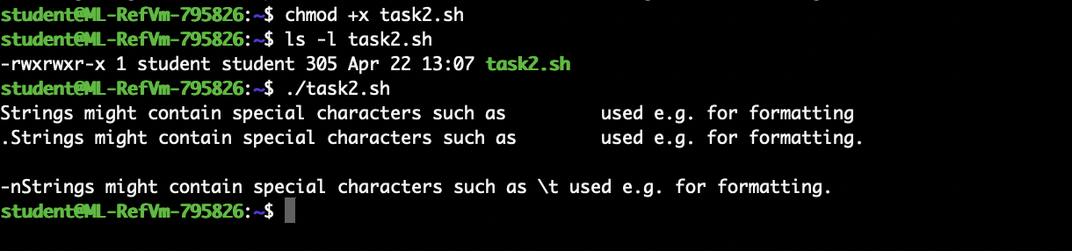

To change the permission of the script and make it executable, we can use “chmod” command that give executable permission to the user and check the permission of the file with “ls -l” and then we can run the script.

Task -4

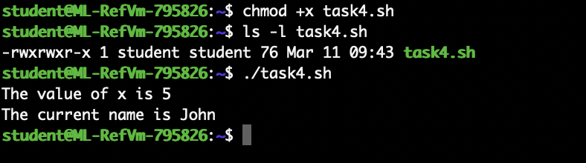

Task -5

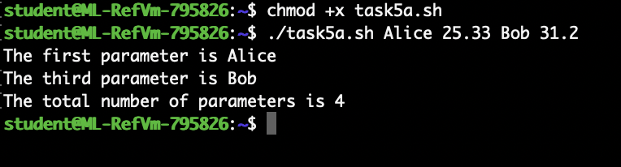

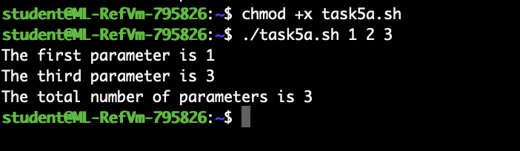

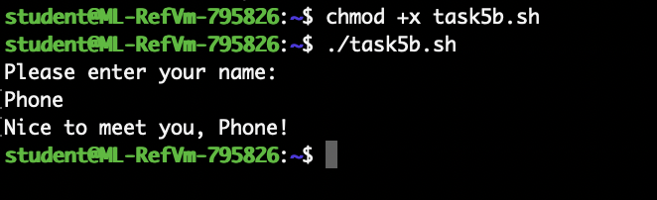

Task -6

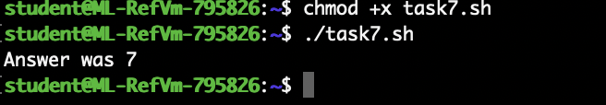

Task -7

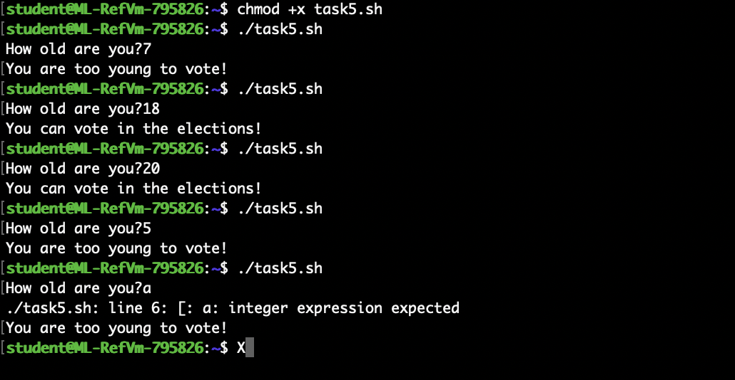

Task -8

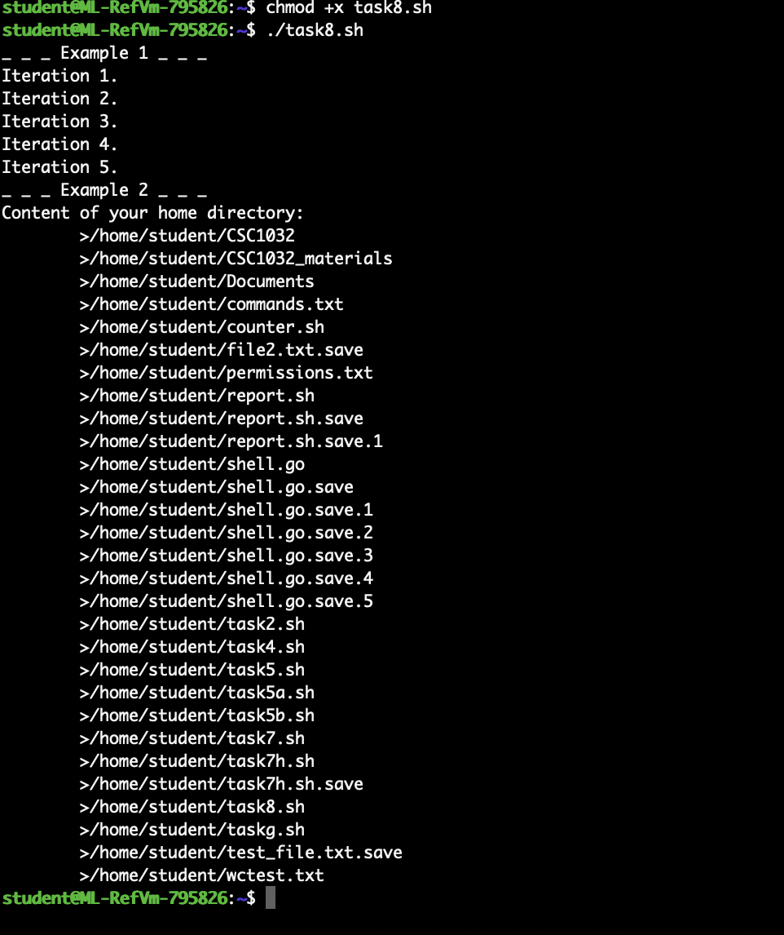

**For Report**

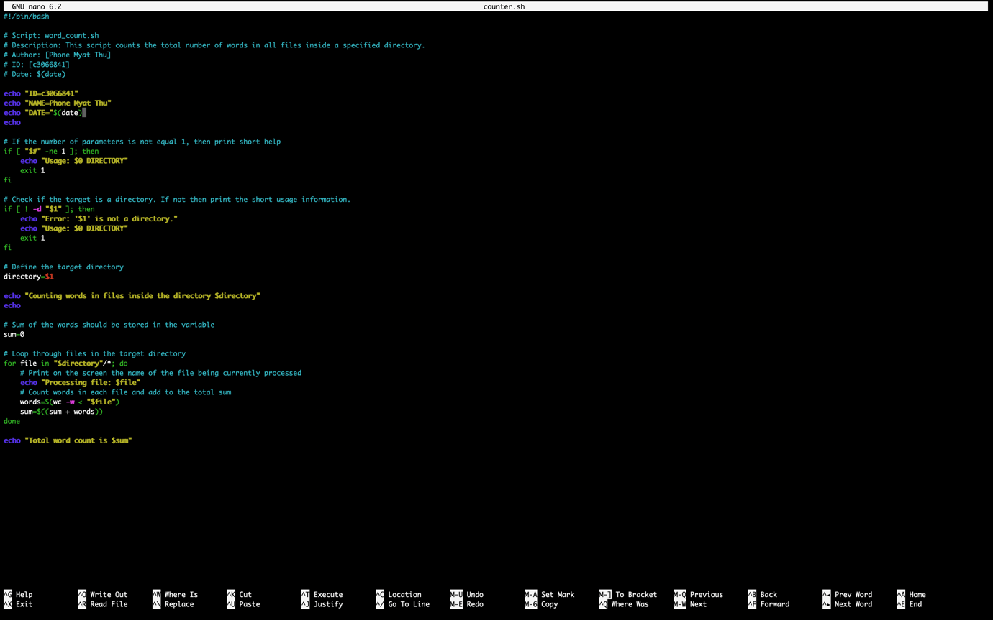

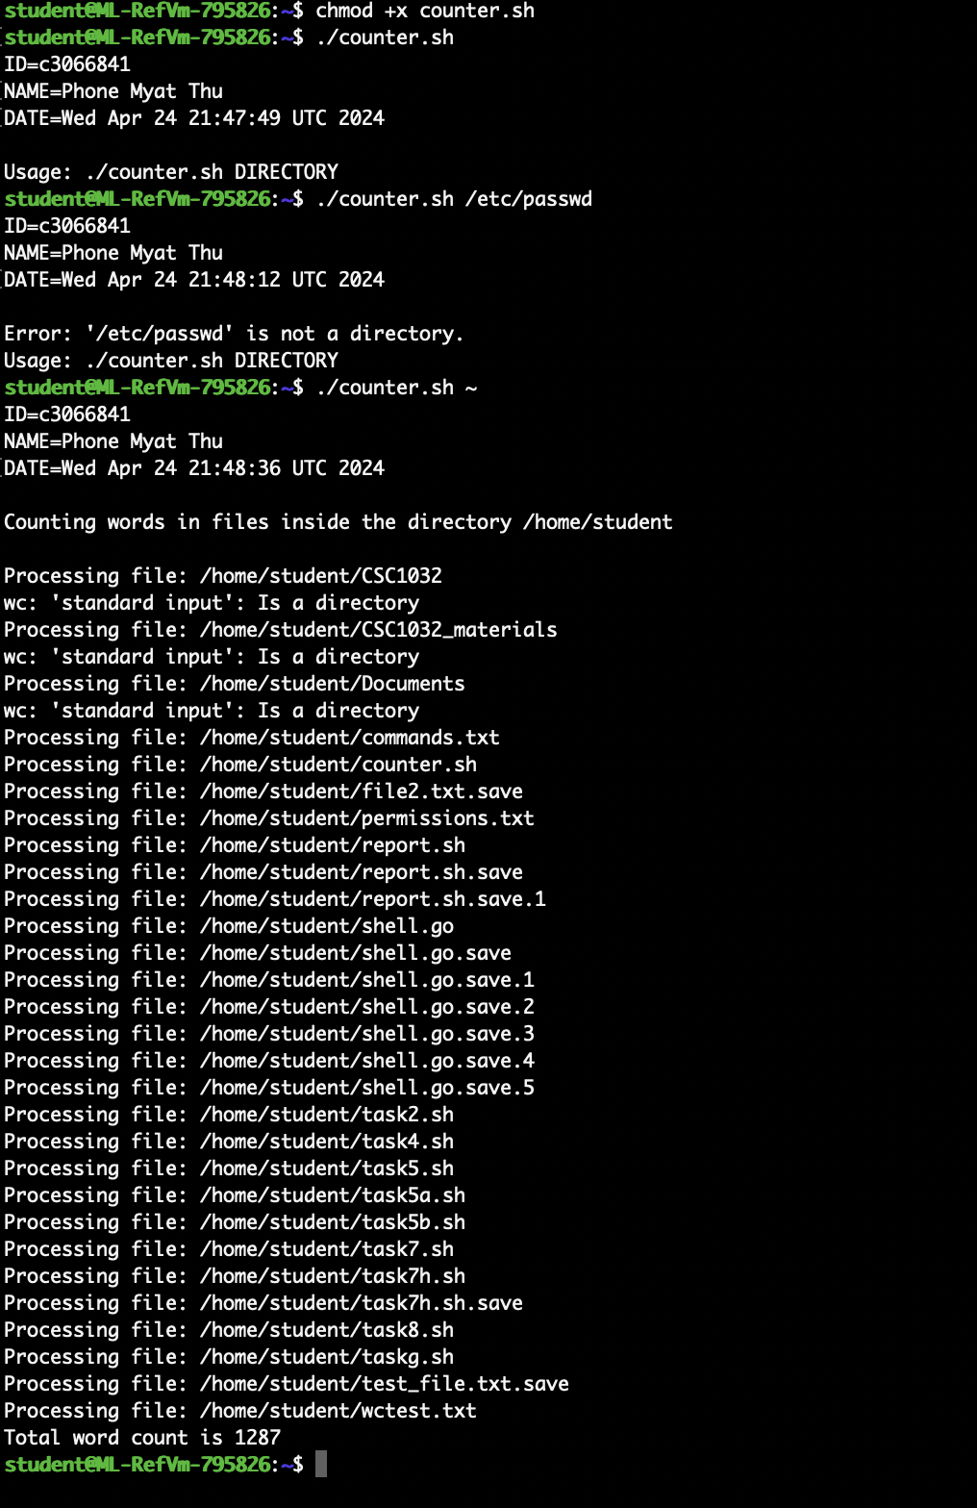

**Week -4**

Task -1a

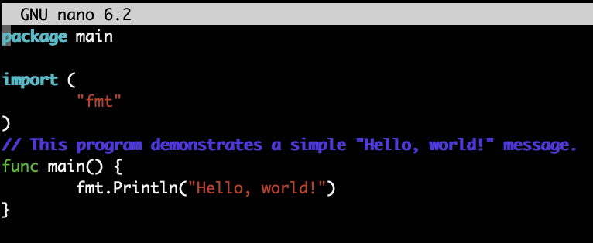

Creating a go file and import “fmt” for formatting and printing and import the main function “Hello, world!”.

Task -1b

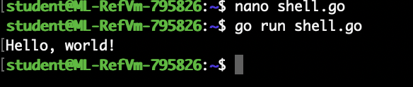

Task -2a

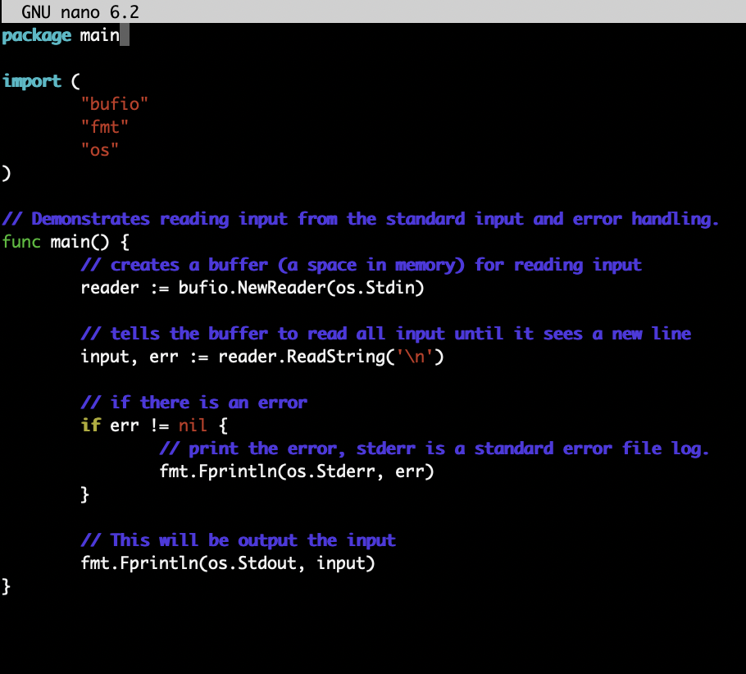

This program reads the line from the standard input and prints it back to standard output. It includes error handling to solve if error might occur during the reading process.

Task -2b

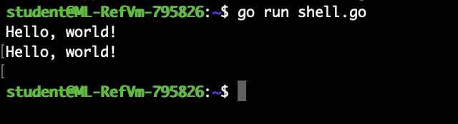

Task -3a

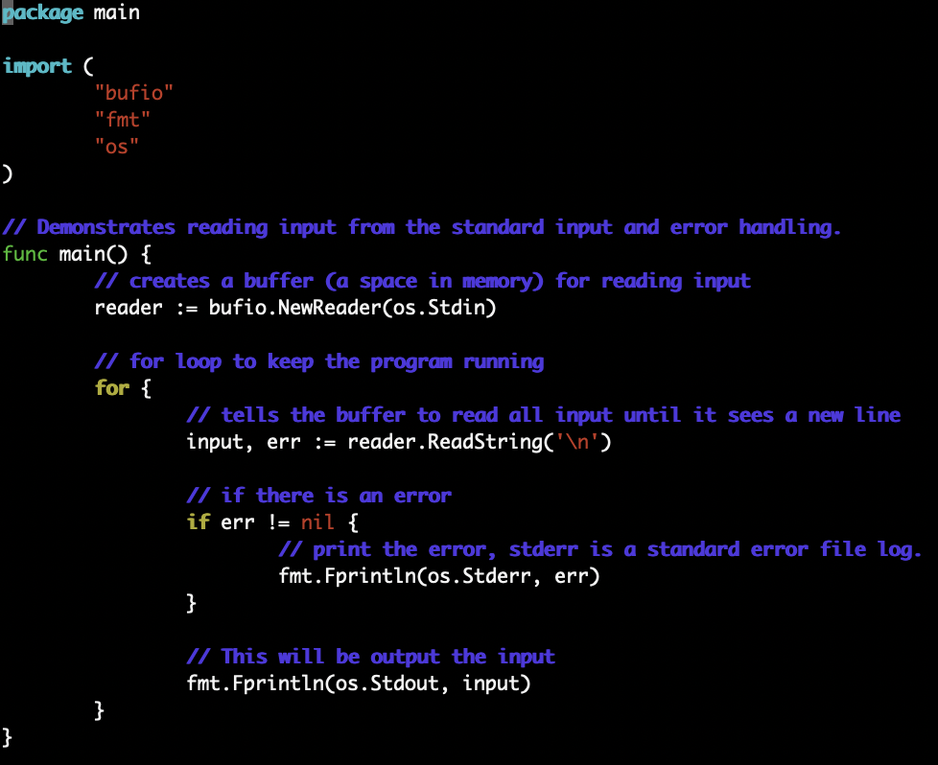

The loop is added in the program to the shell running continuously and accept the input. Even though it runs continuously, the program can be interrupted using “Ctrl+c” as shown in result.

Task -3b

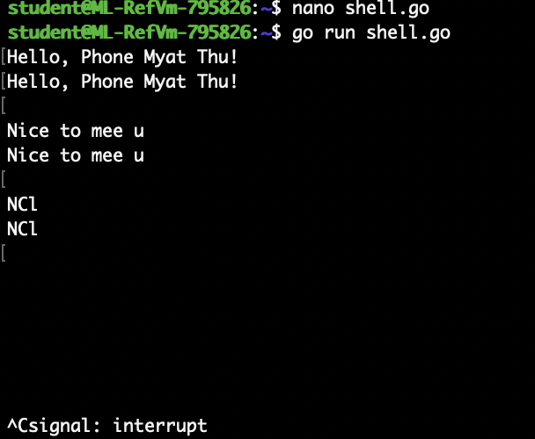

Task -4

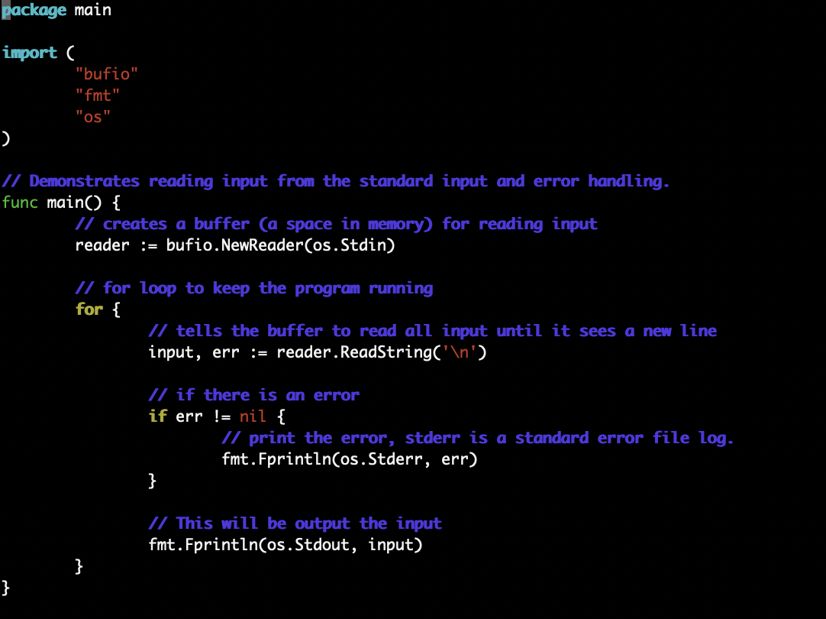

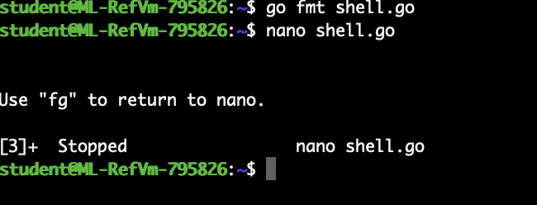

**Week -5**

Task -1

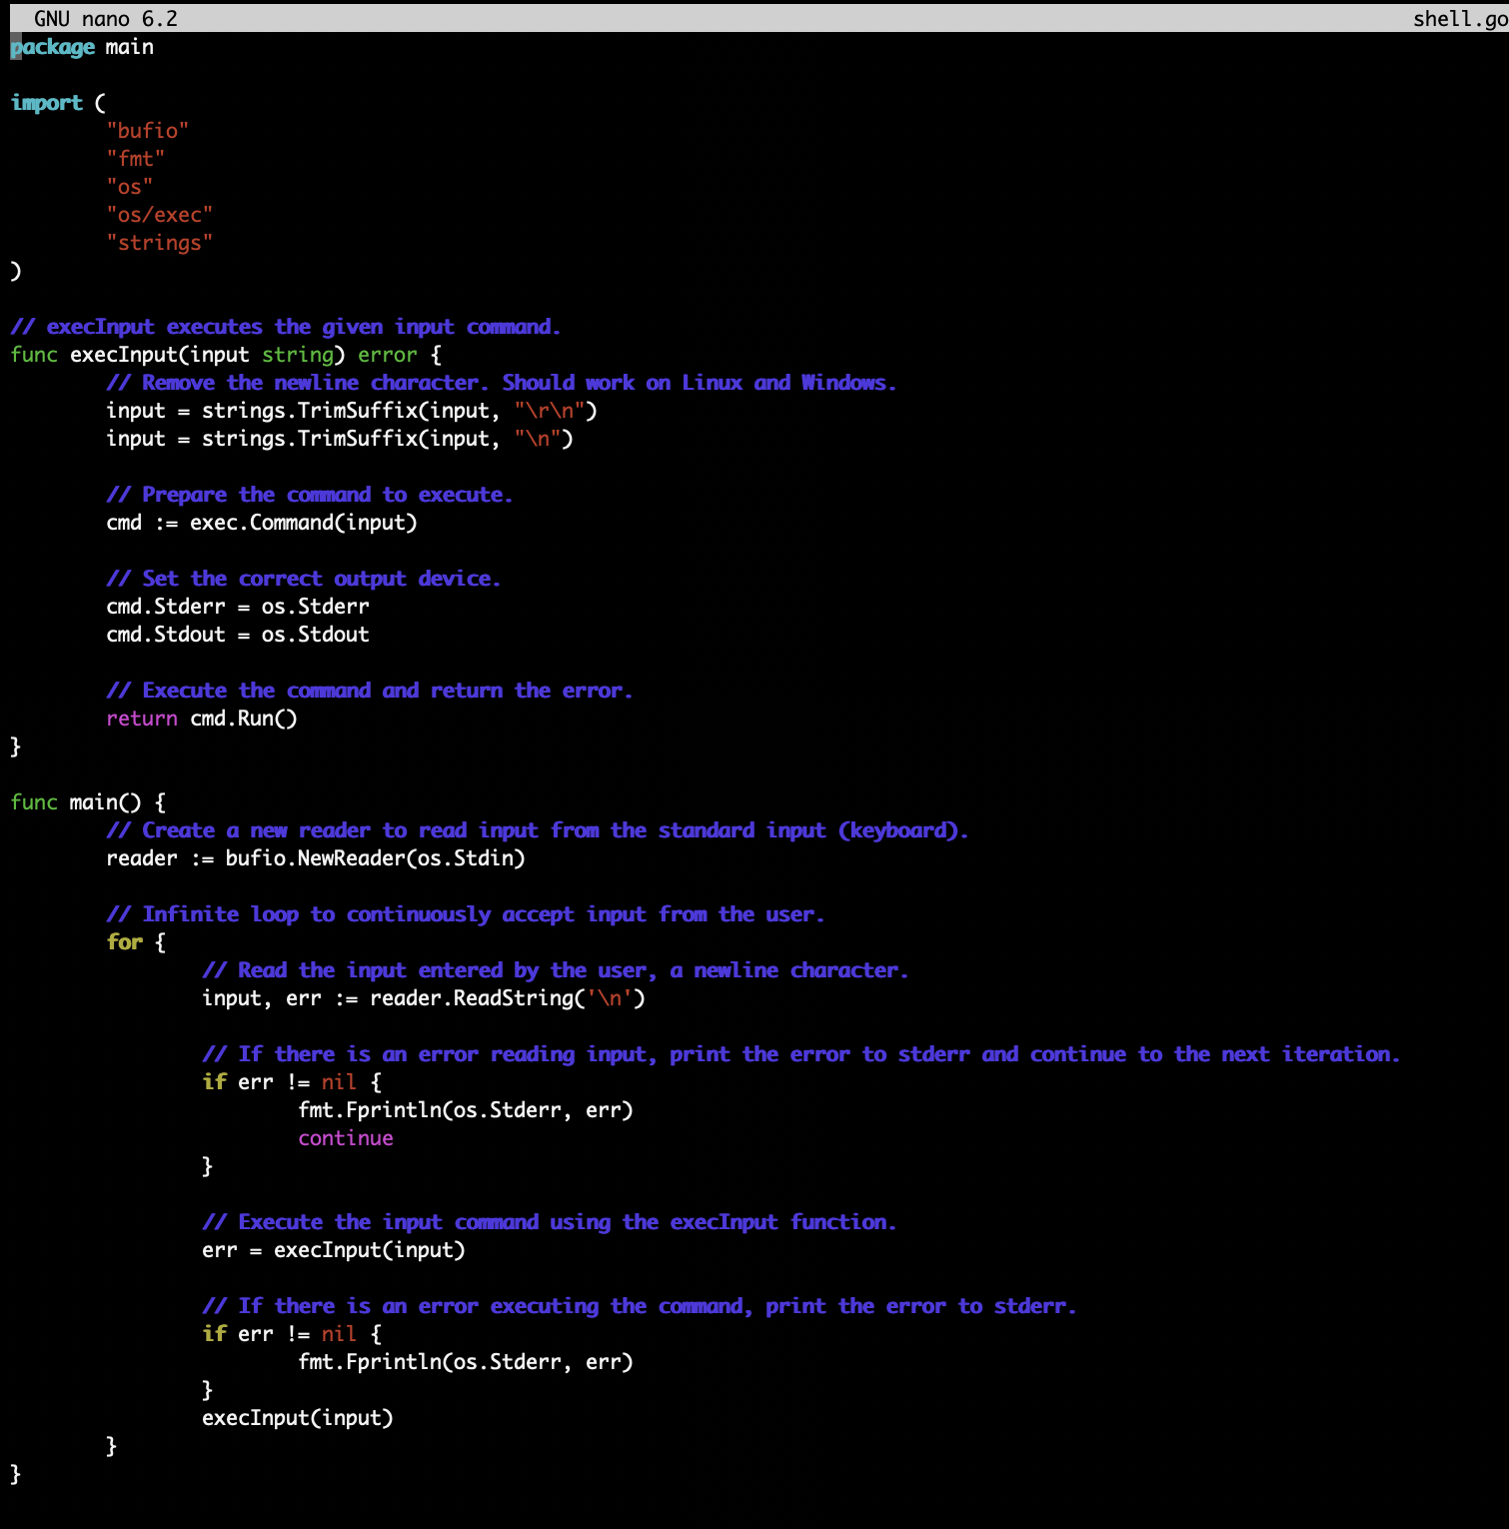

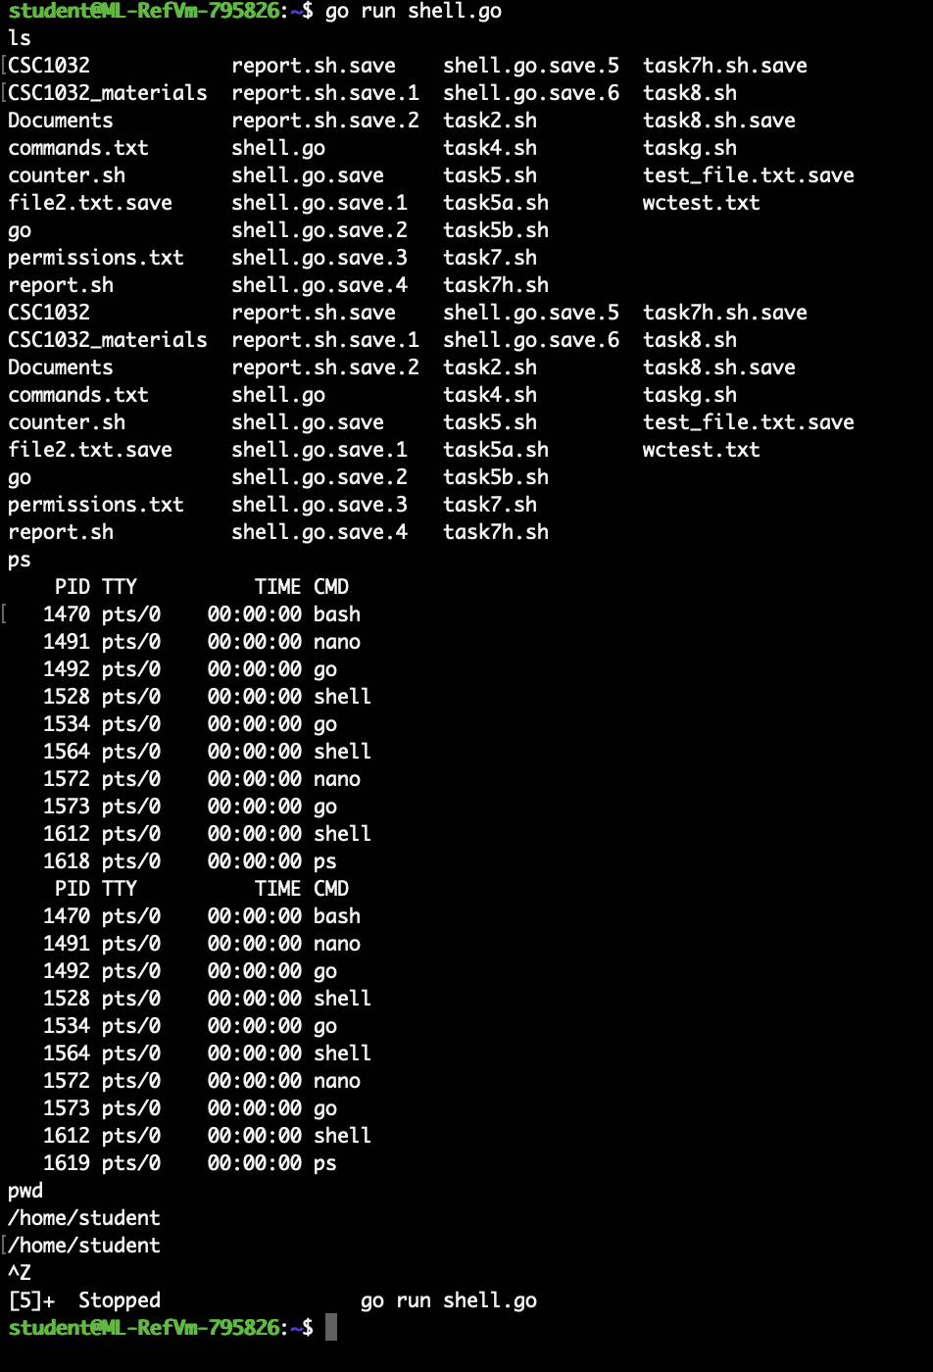

Task -2

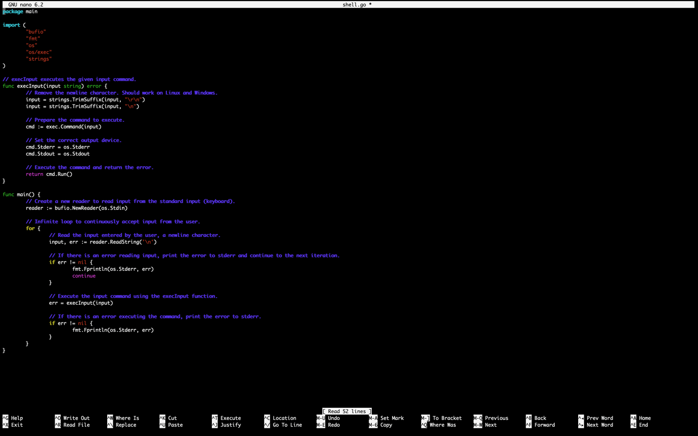

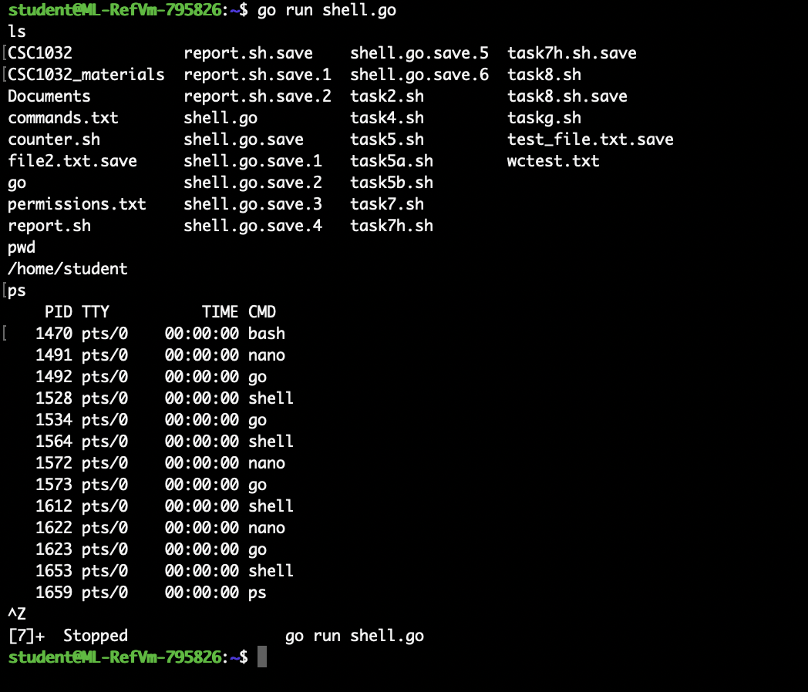

Task -3

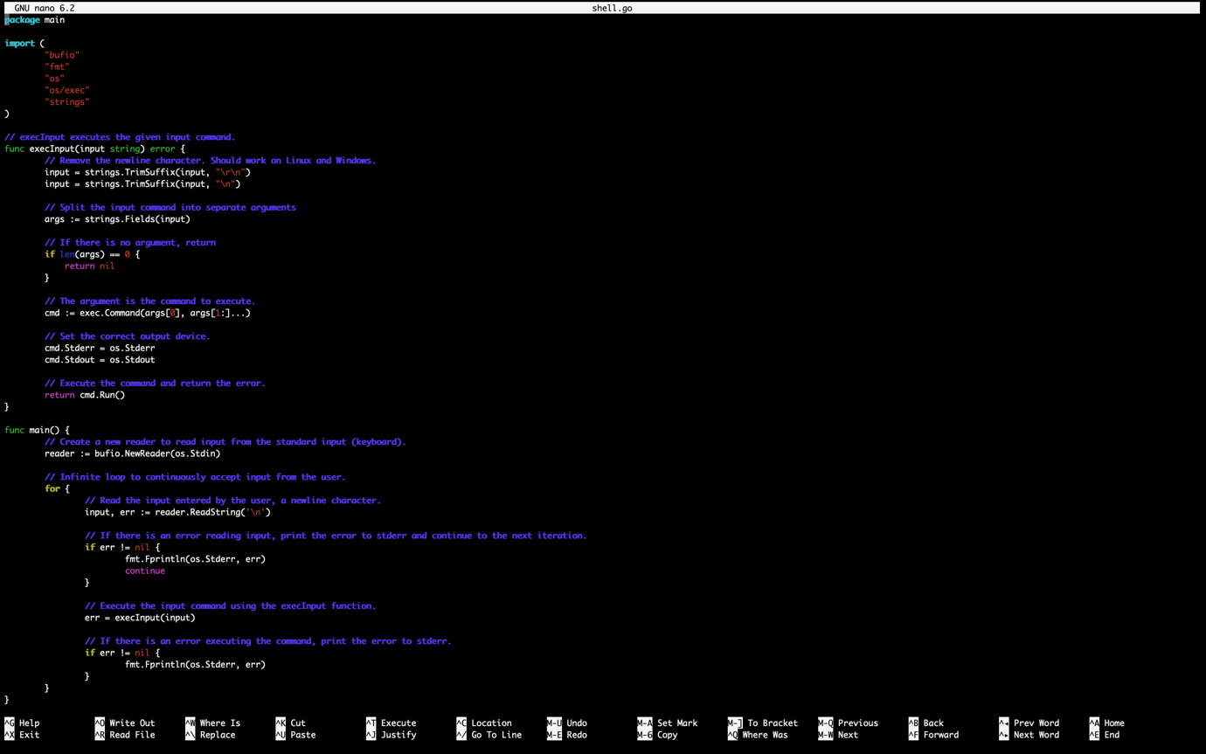

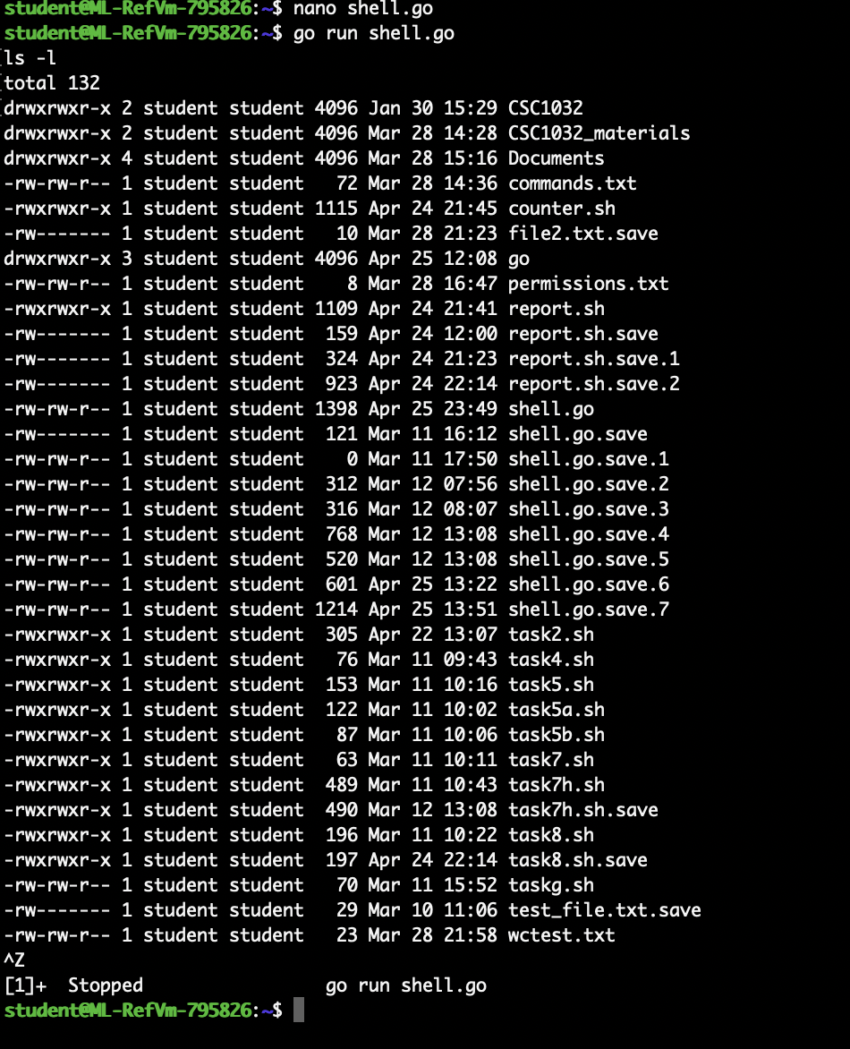

Task -4

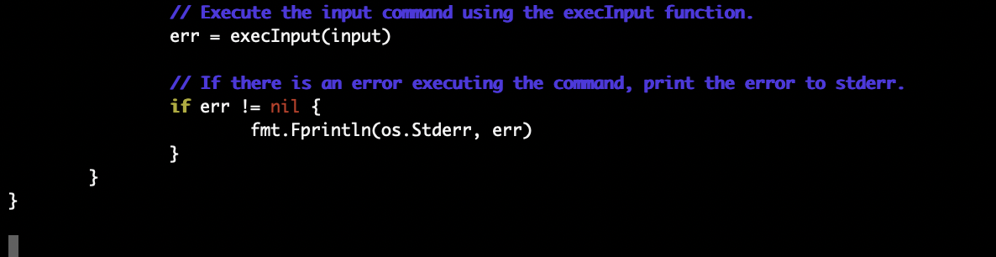

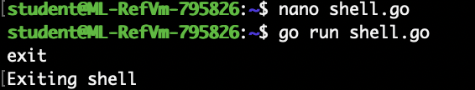

**Week -6**

Task -1

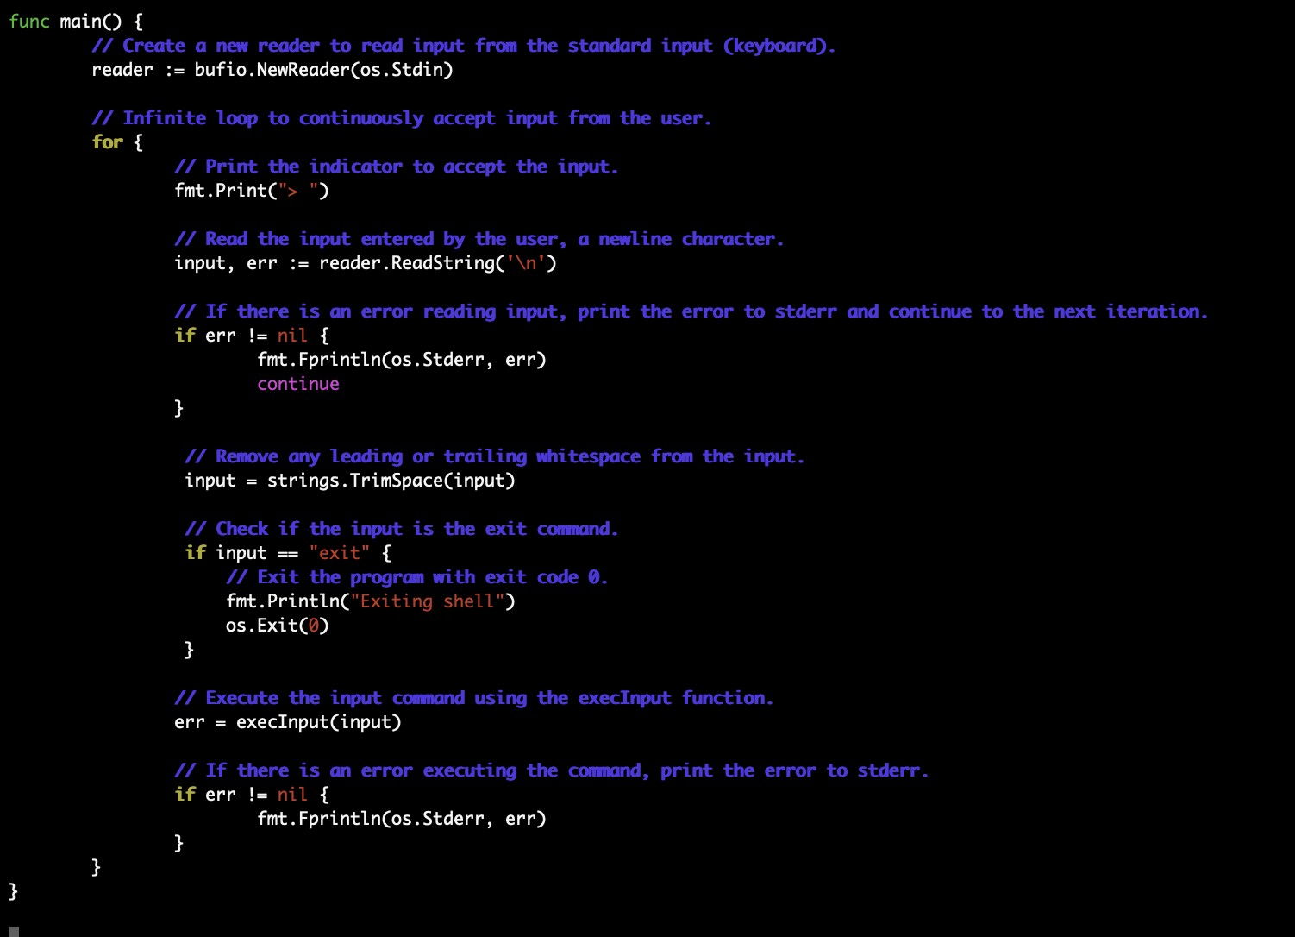

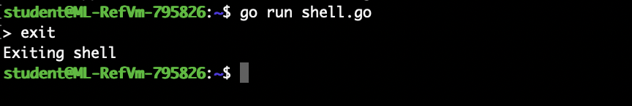

Before reading the input from the user, we print “>” symbol to indicate that the shell is ready to accept the input. The symbol will appear in terminal for the users to type their commands.

Task -2

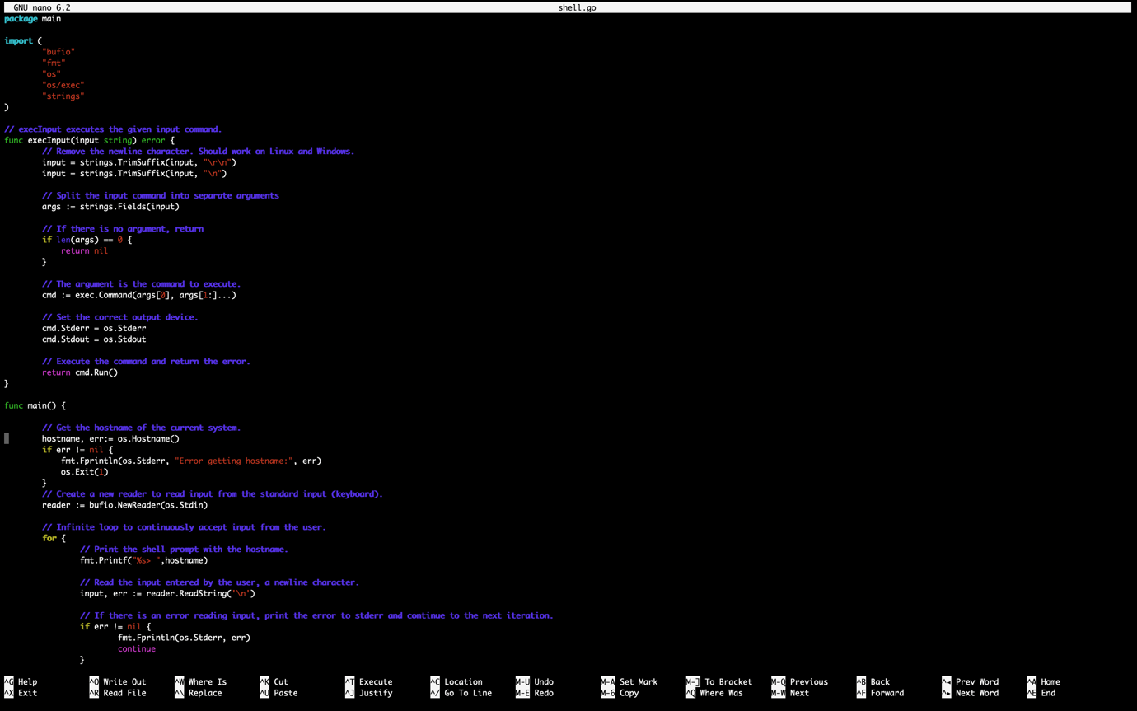

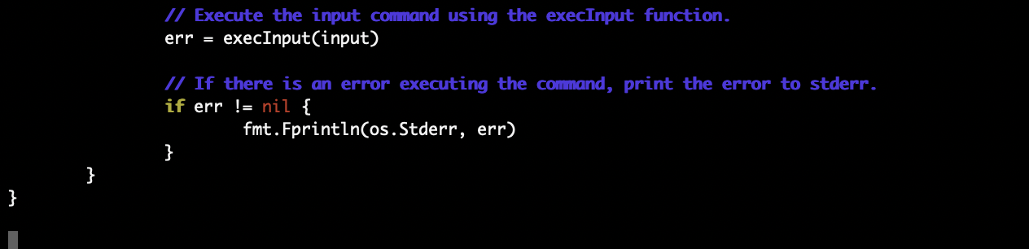

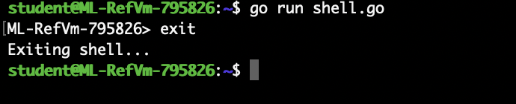

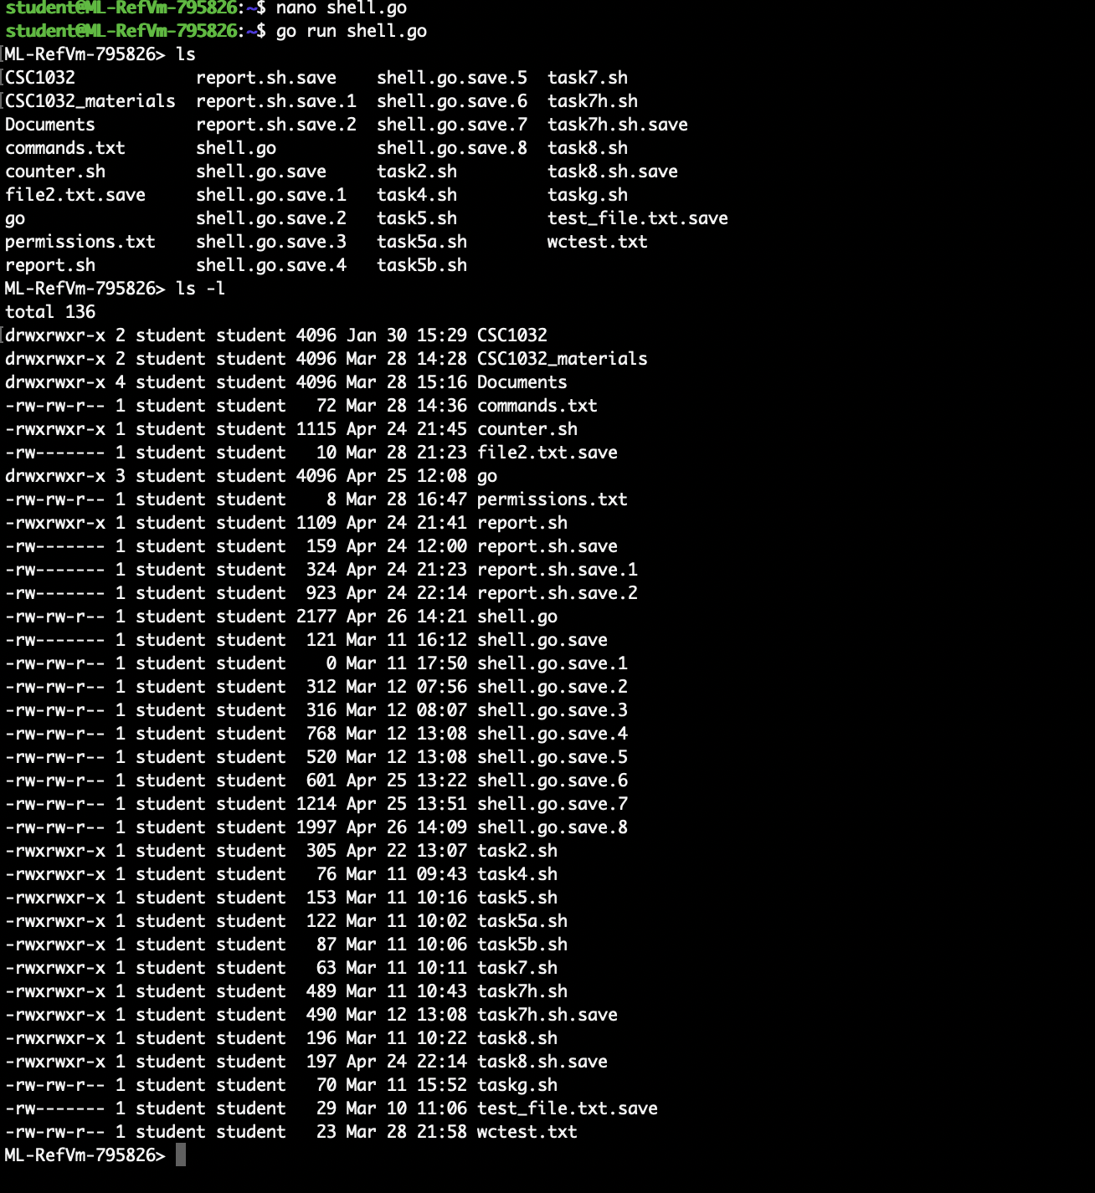

In this program, “os.Hostname()” is used to retrieve the hostname from the current system and the hostname is printed along with “>” indicator to accept the commands from the user.

Task -3

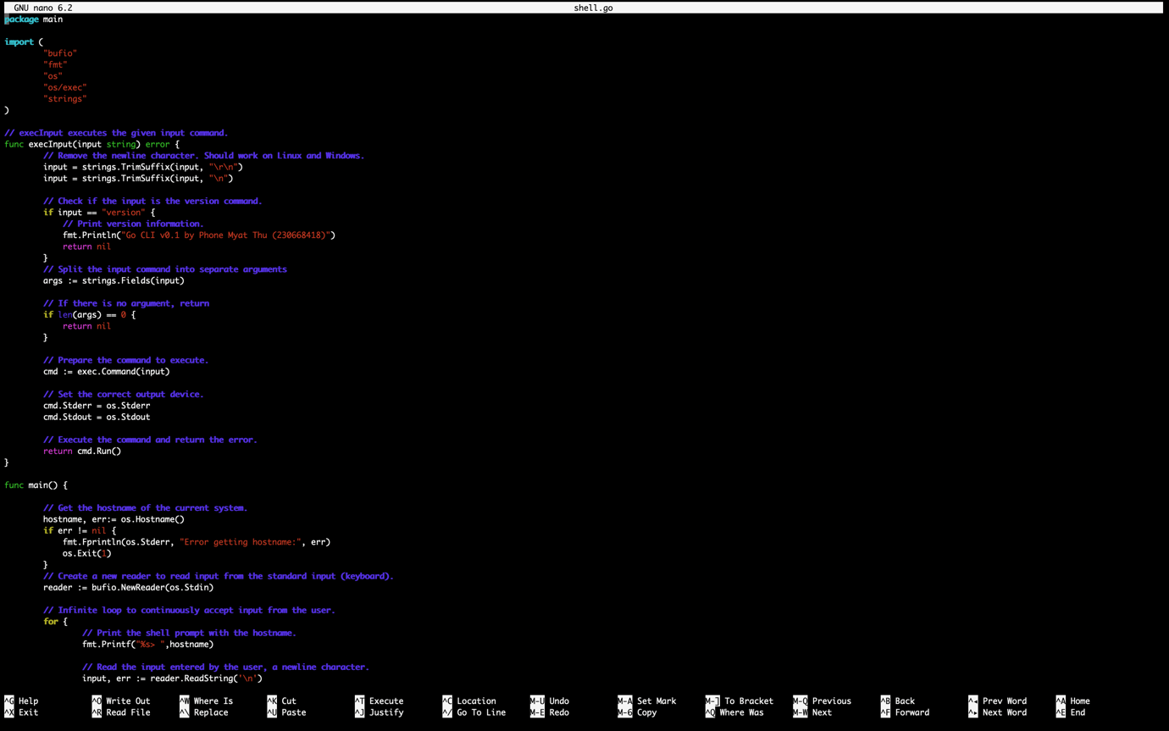

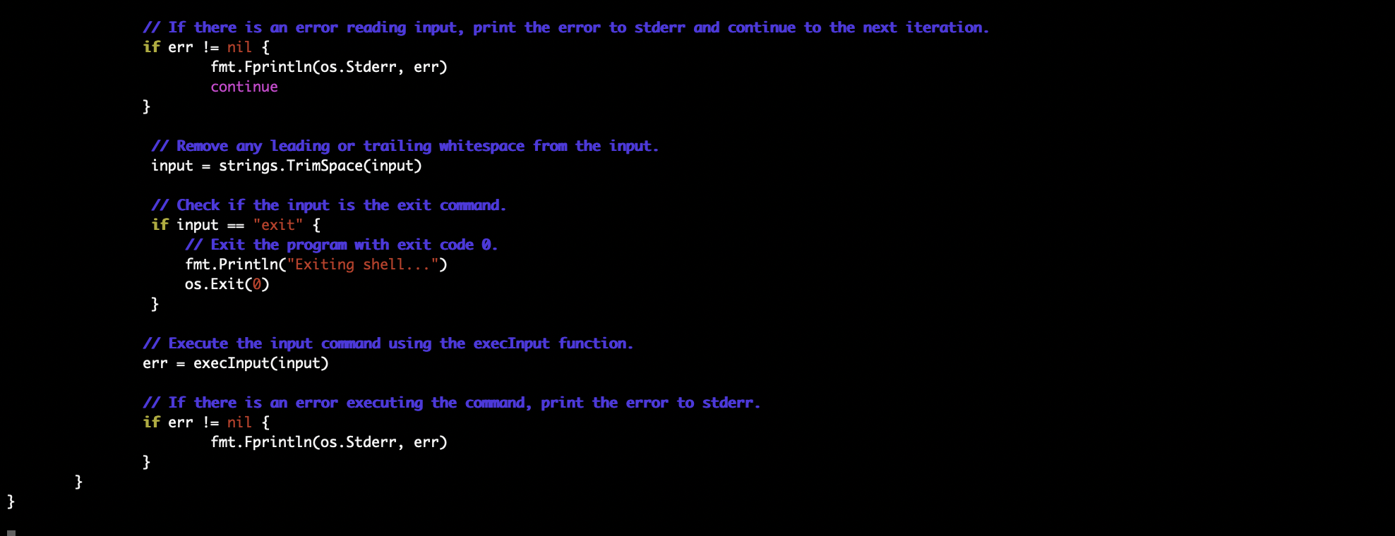

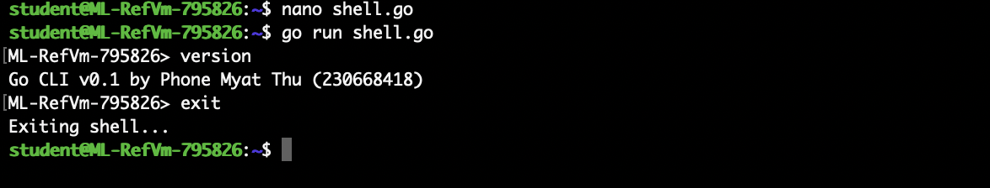

In this program, we check if the input equal to the version command. If user command “version”, the system prints the software version (v0.1) and the student’s name and ID. In my case, the program will print my name “Phone Myat Thu” and student ID “230668418”.